Intro to LAN
DG Interns Hub | Week 1 | TryHackMe Room Writeup

Objective
Learn how local area networks connect devices.

Activity summary
Studied LAN structures and completed the room exercises.

Key learning
Switches, routers, LAN topologies and local connectivity.

Evidence
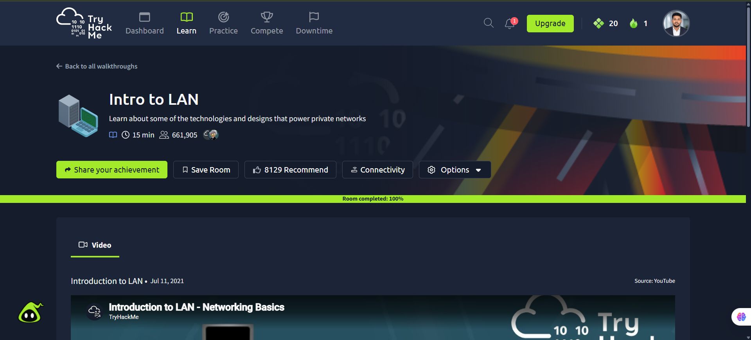
Screenshot: Intro_to_LAN.png
Completion screenshot provided; the original step-by-step room answers were not included in the archive.

